1. **How to use different kinds of python data types in Data Science?**

**Objective:**

* To know about different data types in python.

**Process:**

Data:

* Data is a information about something.
* Its raw in nature.
* We need to convert the unstructured data(raw data) into a structured format in data pre-processing.

Data types in python:

* List
* Tuples
* Set
* Dictionaries
* List:

List is a collection of elements,which is ordered and changeable.

We can add,change,delete an element in a list using index position or inbuilt methods.

Python lists are written with square brackets[].

* Tuples:

Tuples is a collection of elements,which is ordered and unchangeable.

Python tuples are written with round brackets.()

* Set:

Set is a collection which is unordered and unindexed.

Python sets are written with curly brackets.{}

* Dictionaries:

Dictionaries is the most used python data type in data science.

It used to store key:value pair of data.

We can call the key and values independently using inbuilt methods d.key(),d.values().

We can add,remove,change an element in a dictionary.

Key may be a string and value may be a string.

**Input:**

Data set

**Output:**

Examine the behaviour of different data types in python.

**Source Code:**

* List:

#Python list

#creating the list1

list1=['sathish','sangeetha','venkat','sheela','sudhakar']

#Creating the list2

list2=[23,24,25,22,21]

#print the list1

print(list1)

#print the list2

print(list2)

* Tuples:

#Python tuple

#creating the tuple1

tuple1=('sathish','sangeetha','venkat','sheela','sudhakar')

#Creating the tuple2

tuple2=(23,24,25,22,21)

#print the tuple1

print(tuple1)

#print the tuple2

print(tuple2)

* Set:

#Python set

#creating the set1

set1={'sathish','sangeetha','venkat','sheela','sudhakar'}

#Creating the set2

set2={23,24,25,22,21}

#print the set1

print(set1)

#print the set2

print(set2)

* Dictionaries:

#Python Dictionary

#creating the dictionary

dict1={'sathish':23,'sangeetha':22,'venkat':24,'sheela':26,'sudha kar':25}

#print the dictionary

print(dict1)

#Check the type of varible dict1

print(type(dict1))

* **How to use python dictionary in data science?**

#pandas library used for data analyse

import pandas as pd

#creating the dictionary having details of employees in a company

dict1={'name':['sathish','nandhini','sangee','venkat','sudhakar'],' Age':[23,21,22,20,21],'salary':[100,50,150,250,300]}

#creating a dataframe and pass the dictionary elements.

df=pd.DataFrame(dict1)

#print the dataframe.

print(df)

* **How to read a file using python pandas?**

#pandas library used for data analyse

import pandas as pd

#Reading the data from a CSV file

data=pd.read_csv('/home/soft27/soft27/Sathish/Pythonfiles/

Employee.csv')

#creating a dataframe and pass the data from the file

df=pd.DataFrame(data)

#print the dataframe.

print(df)

* **Screen shots:**

**List:**

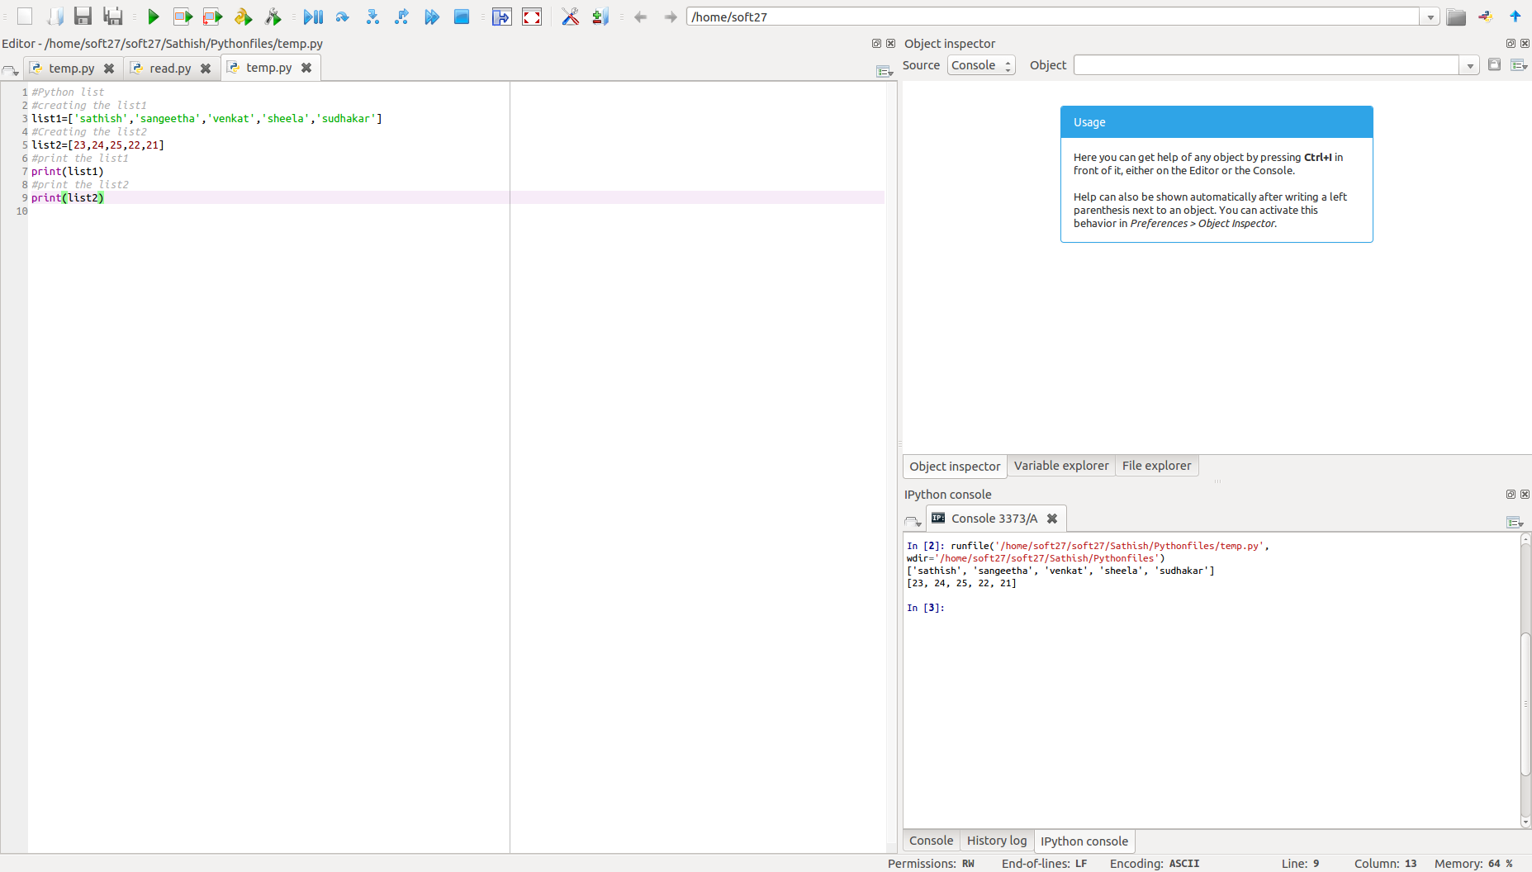

**Tuple:**

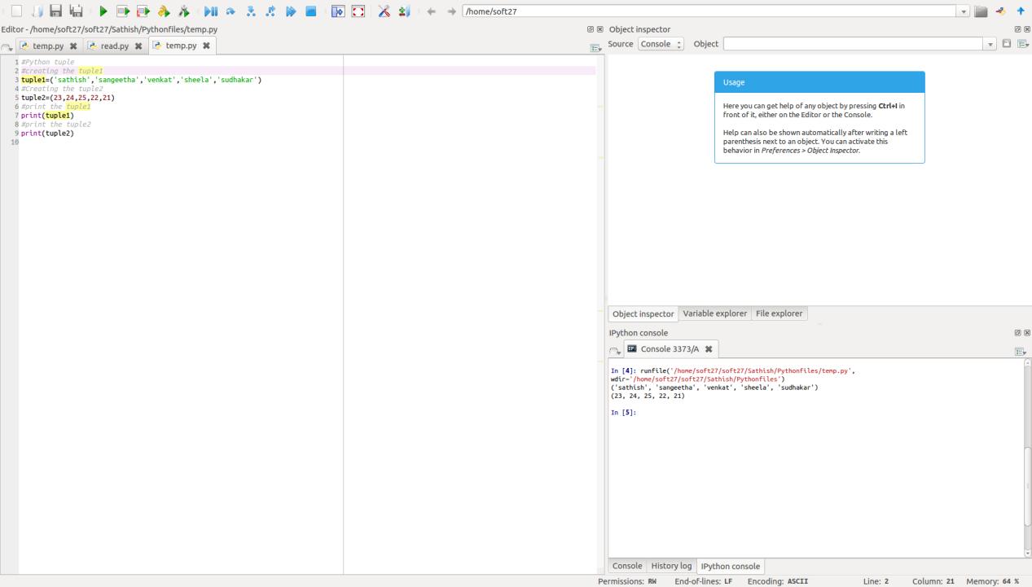

**Set:**

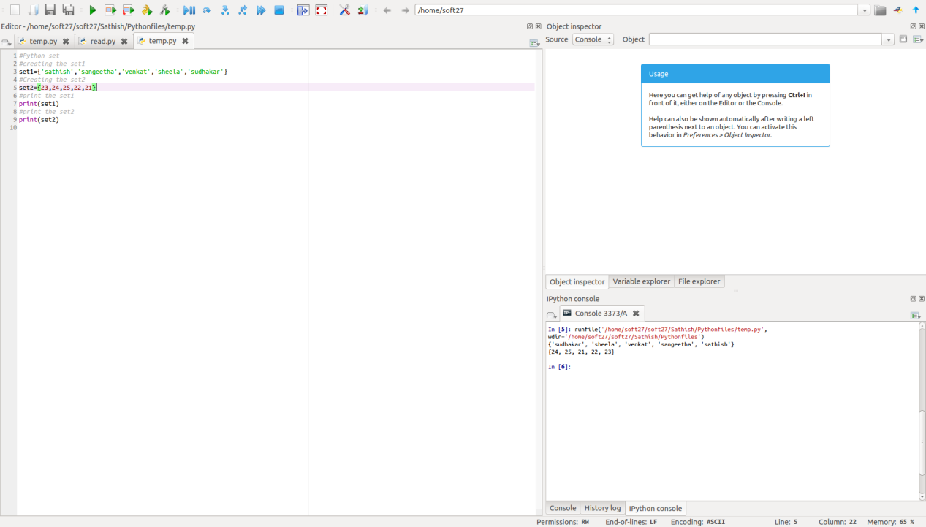

**Dictionary:**

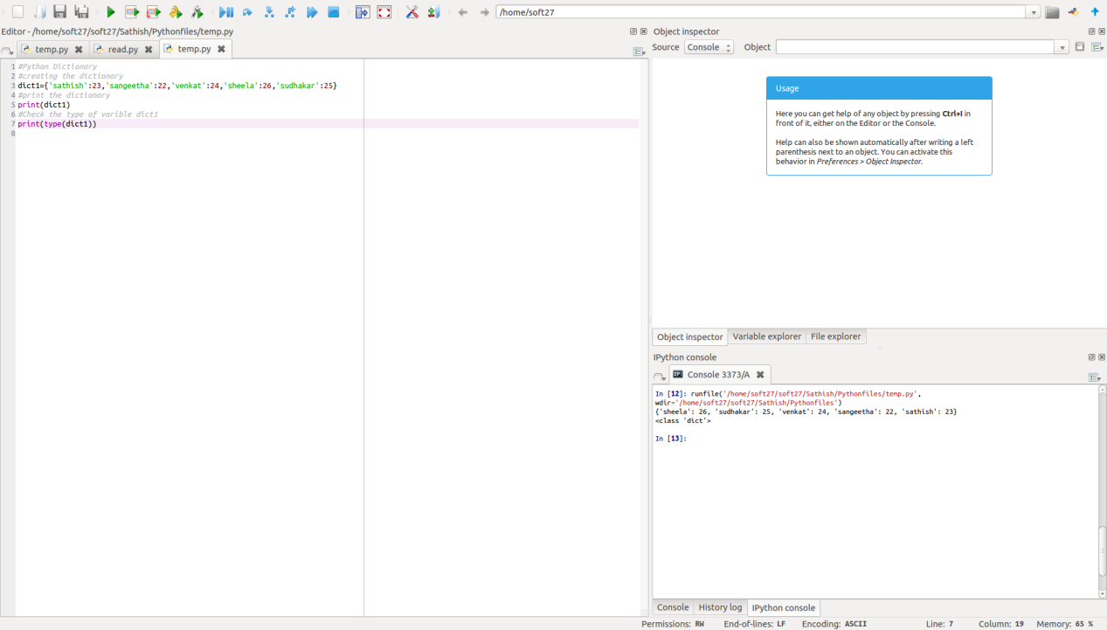

**Data Frame:**

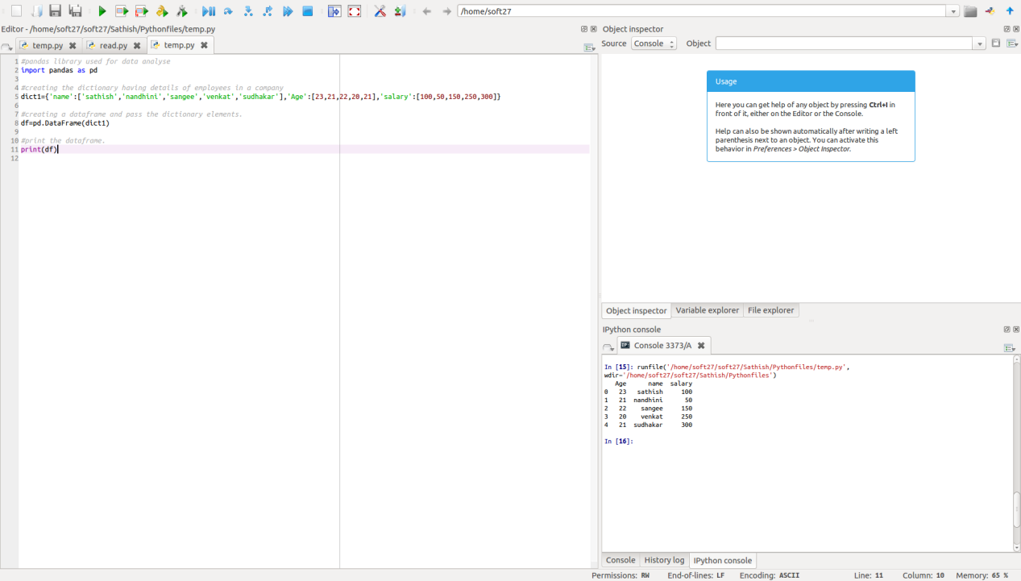

**Reading Files:**

